How to Export a Linux Instance, Linux Archive, or Windows Archive
If you wish to export a Cloud Concierge Linux Instance, Linux Archive, or Windows Archive, follow the below steps. If you wish to export a running Windows Instance, please see the document How To Export A Running Windows Instance on our Support area.
Support: We only support the export and Cyberduck process. Using IBM Aspera or FTP’ing it somewhere else or modifying/converting the VHD files is not supported by the Cloud Concierge Team.
Disclaimer: Please not that if you run into a restart issue, you may need to remove the Xen drivers before starting. See pages 6-7 for those instructions.

Step 1: Clean up your Instance and delete any files/data to reduce the size of the Instance.
Step 2: On the Cloud Concierge ‘MyCloud’ page, create an Archive by clicking the ‘Archive’ button of the Linux or Windows Instance you wish to export. The process will take 4-8 hours depending on how large your Instance is.
Step 3: Locate your Archive on the ‘Provisioning’ webpage by clicking the ‘My Templates’ bubble.
Note: If your Archive is in yellow highlight, it is not ready to be exported yet.
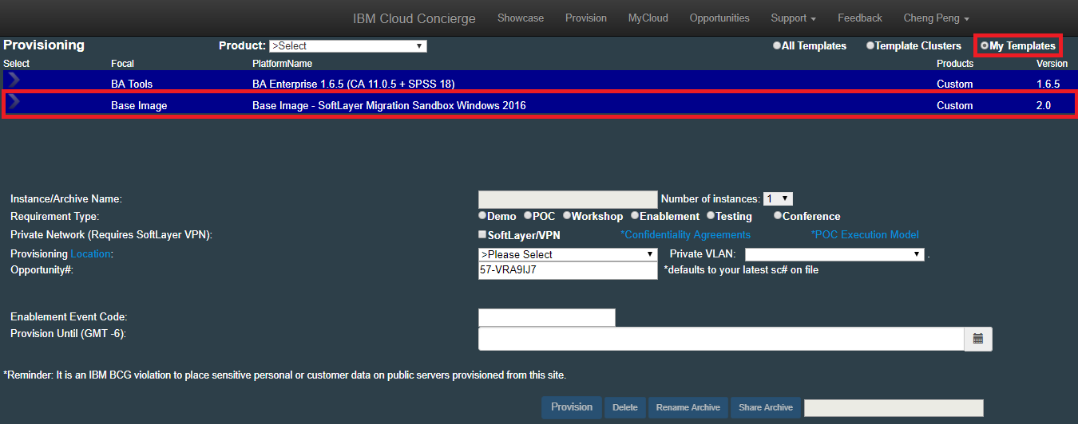
Step 4: Email the ASKIBM team requesting your Archive be exported
Note: The export takes, on average, 6-12 hours to complete.

Step 5: While you wait for the export to complete, log into Cloud Concierge and provision the system titled ‘Softlayer Migration Sandbox’ on the ‘Toronto’ datacenter and choose the ‘Testing’ bubble. Do not select the ‘SoftLayer/VPN’ option. The Sandbox will allow you to download your export from the Softlayer infrastructure onto the Sandbox.
Step 6: Email the Cloud Concierge Support Team asking for an extension of your Softlayer Migration Sandbox. You will be granted a maximum of 5 business days which is plenty of time to download the Export and then push it to another site and/or convert it or compress it with Winrar or 7Zip.
Step 7: RDP into your Softlayer Migration Sandbox Instance
Step 8: Double click the Cyberduck shortcut on the Desktop
Step 9: If prompted to upgrade Cyberduck, please upgrade.
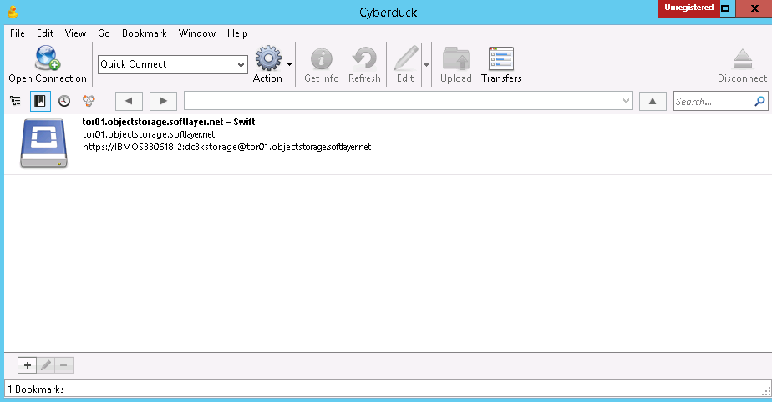
Step 10: Double click the tor01.objectstorage.softlayer.net bookmark
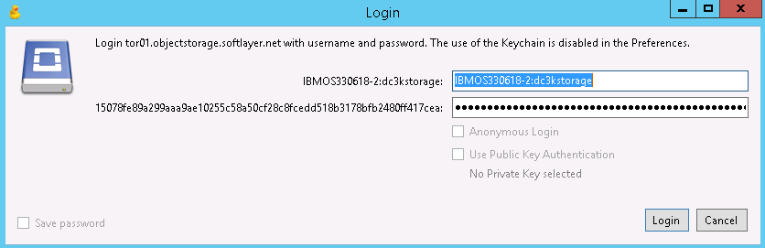
Step 11: If the password is needed, open the Desktop shortcut to the Cyberduck password and copy and paste it into the Login box
Step 12: Click Login.
Step 13: Double click the User Exports folder containing your export
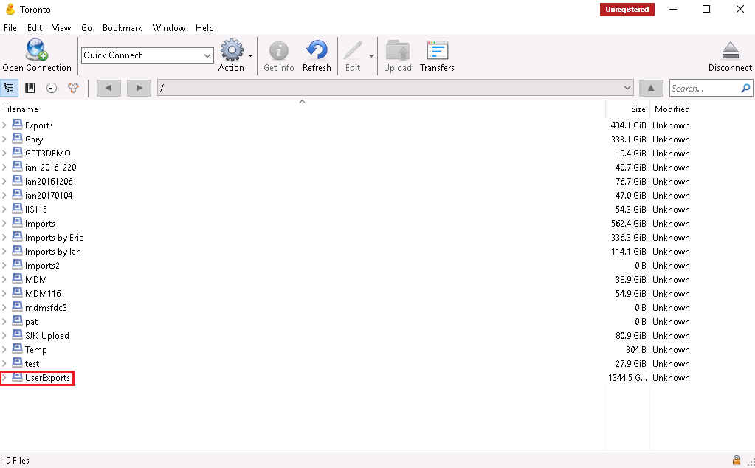
Step 14: Highlight only the .VHD files (not the folders) that refer to your archive. Ignore the 0B file sizes.
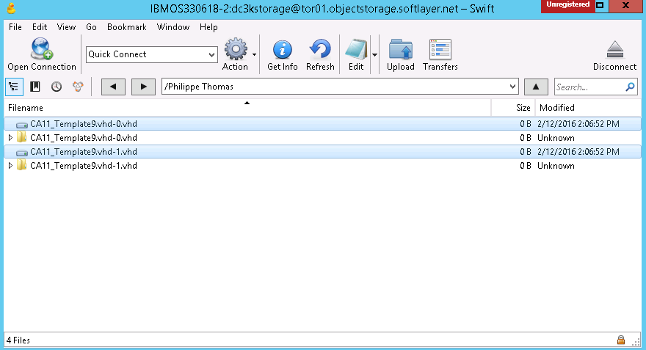
Step 15: Right click the VHD files only (not the folders) and choose Download To…
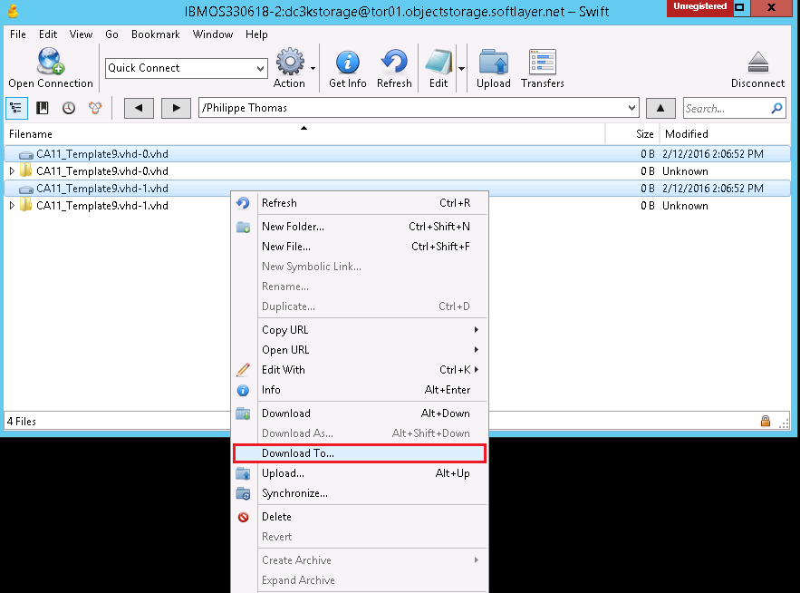
Step 16: Save the export on the D drive of the Softlayer Migration Sandbox Instance. You will see a Transfers popup window showing the status of the download. The download speed should be quite fast at about 1GB of data per 5 min, thus a 100GB export would be about 500 minutes or 7.5 hours. Cyberduck does not state how large the download is.
Note: As shown below, it’s possible that Cyberduck will report that the download is incomplete. Often this is false. To test, simply open the VHD file using WinImage (on the Sandbox Desktop) and browse the contents of the VHD. If you can browse the VHD, the download is complete. If you are unable to browse the VHD, be sure the location you are saving the VHD is not out of disk space. Finally, if you need support on the Cyberduck download process, please provide a screenshot of the exact error message, the VHD(s) you are trying to download, the Sandbox email confirmation, and any other helpful information.
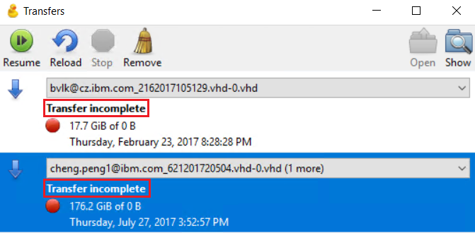
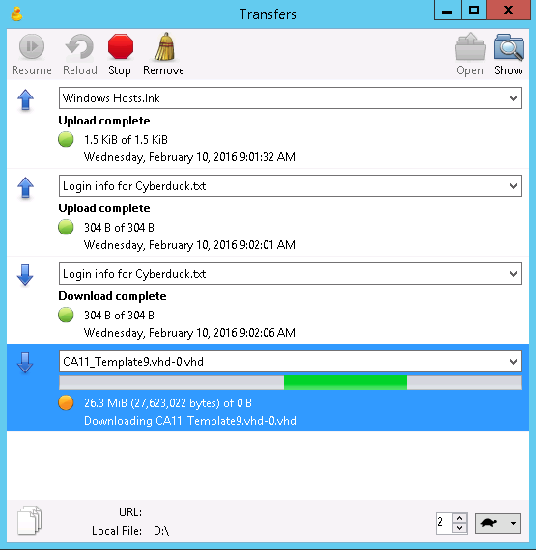
The export should now be on your Softlayer Migration Sandbox Instance. You may send it to another location using FTP or IBM Aspera or you may use WinImage (on Desktop) to convert and prepare your export for VMWare Workstation or other virtual machine software packages. You may wish to install WinRAR or 7Zip and compress your VHD or other files you created before pushing them off the Instance…this will save you both time and bandwidth…typically VHD files compress about 40% smaller which is considerable if you have a 100GB original set of files. The Softlayer Migration Sandbox Instance contains about 70GB free on C: and about 500GB free on D. Uploading a 100GB file to IBM Aspera takes 4 hours which is ½ the time it takes to download 100GB from Softlayer.
Support: We only support the export and Cyberduck process. Using IBM Aspera or FTP’ing it somewhere else or modifying the VHD files is not supported by the Cloud Concierge Team. Please see the following documents to convert to VMWAre and using IBM Aspera:
Convert to VMWare: https://ibm.box.com/s/0018umjyjgeikuzye1ff30izwn0ed4d1
Using IBM Aspera: https://ibm.box.com/s/vzrrjyxrk6m4brvoigemuvbl1y0nkzs1
Although the conversion process of VHD to VMWare is not supported by ASKIBM Support, a few suggestions for problems using the VMWare formatted files are:
- Ensure you are using VMWare Workstation 10.x or newer
- Boot the VM into Windows Safe Mode and uninstall Xentools and reboot
- Ensure the VM is properly configured for your machine’s hardware (especially CPU and cores)
- Ensure your BIOS is set properly to run VMs

Some users obtain the following error message when trying to export the Windows 2012 from SoftLayer to a local computer:

- “Your PC ran into a problem and needs to restart… SYSTEM_THREAD_EXCEPTION_NOT_HANDLED”

To workaround this issue, please follow the instructions listed prior to the archive process:

Step 1: Uninstall all Citric and Xen software

Step 2: In Device Manager, select “show hidden devices” and remove all Xen or Citrix devices.
Note: Look for disk drives, storage devices, network and system bus devices and then reboot.
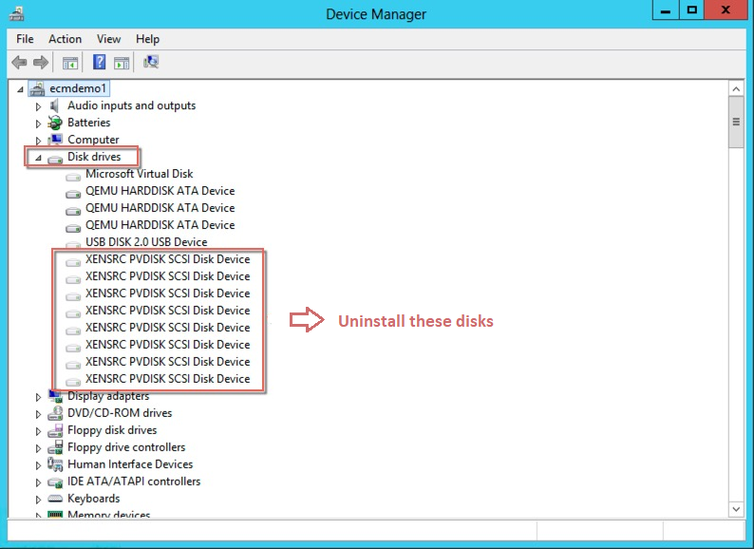
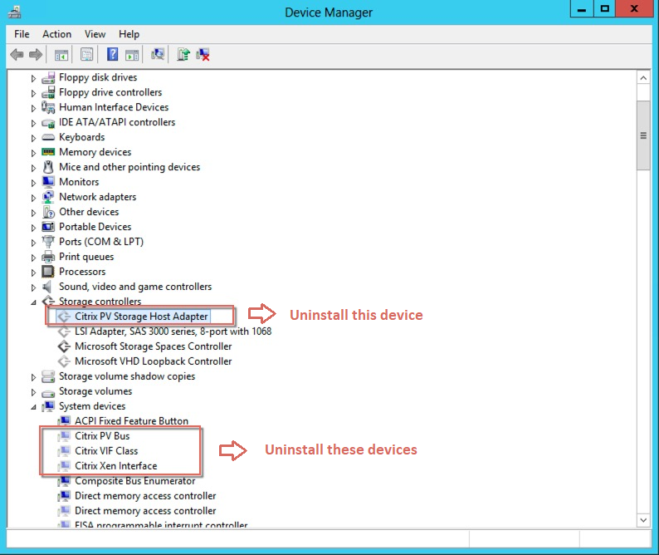
Step 3: In Safe Mode, delete all xen*.* files from all subdirectories of Windows\system32\
Note: Subdirectories include system32, system32\drivers, system32\driverstore\filerepository

Step 4: Convert your computer

Step 5: If the error message shows up during the botting of your laptop, go back and delete the Xen*.* files again using the recovery mode command line.

Note: In recovery mode, it is a little bit trick to find which drive is your real C drive as the letter will change, but it will not be the X: drive since that is the rescue partition.

You will also need the administrator password to login to recovery mode which is found on your ‘MyCloud’ page. If it is not easily visible, the administrator password is also the same as the SoftLayer console password.

